Image | Year | Aircraft Description (click aircraft for details) | Price
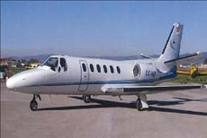 | 1982 | CESSNA CITATION II  9,163 TTSN, Good condition. Flight Rules IFR.   NAVIRNET - ESPAÑA  www.navirnet.net  Number of seats: 10  Location: Spain | 1.770.000 € (Euros)
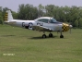 | 1948 | A Navion  3,350 TTSN, 550 SMOH, 40 SPOH. Very Well Maintained Canadian Aircraft. | $85,000 USD
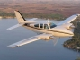 | 1972 | Beech Baron E55  5,900 TTSN, 1,400 SMOH (L/R). Well Maintained American Registered Aircraft. NDH. | $132,000 USD
 | 1975 | Cessna 172M Hawk II  5,004 TTSN, 0 SMOH. Very Nice aircraft. Owner Must Sell Right Away! | Make an Offer!
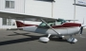 | 1977 | Cessna 172N  2,188 TTSN,656 SMOH. Painted in 2005, Annual Completed in Sept 2007. Hangared Since Painted in 2005 | Make an Offer!
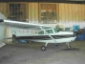 | 1978 | Cessna 172N  5,116 TTSN, 1,030 SMOH, 1,030 STOH. Long Range Fuel Tanks, NDH. Owner must Sell !! | $96,000 USD
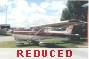 | 1980 | Cessna 172N  1,900 TTSN, 160 H.P Lycoming Engine. No Damage History. Well maintained Canadian Aircraft. | $97,000 USD
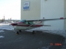 | 1980 | Cessna 172N SkyHawk II  9,565 TTSN, 2167 SMOH. NDH, well maintained aircraft.  Priced for Quick Sale! | $78,000 USD
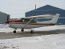 | 1981 | Cessna 182RG II  2,560 TTSN, 1,130 SMOH. 8 SPOH. Always Hangared, Well Maintained Canadian Aircraft. | $140,000 USD
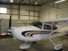 | 2000 | Cessna 182S  349 TTSN. Variable 3 Blade Prop, IFR Certified. NDH, Millennium Edition. | $240,000 USD
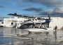 | 1985 | Cessna 208 Caravan Amphibian  7,604 TTSN, 3,768 SMOH. Well Maintained Commercial Aircraft On Wipline 8000 Amphib Floats. Known Ice Certified. | $1,620,000 USD
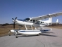 | 1993 | Cessna 208 Caravan Amphibian  632 TTSN, One Owner Aircraft, No Salt Water Operation, Complete Records, No Damage History, Aircraft is Like New! | $1,755,000 USD
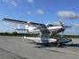 | 1998 | Cessna 208 Caravan Amphibian  955 TTSN, Garmin 530, An Absolutly Pristine One Owner Aircraft!  Full De-Ice, No Damage History and Exceptional Maintenance! | $1,630,000 USD
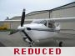 | 1982 | Cessna 210N  4048 TTSN, 1091 SMOH, IFR Certified, Prop De-Ice, Loaded!  This Aircraft Has It All! Immaculate Inside and Out! Owner Must Sell Quickly! | Make An Offer!!
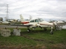 | 1973 | Cessna 310Q  8,500 TTSN, 520 SMOH (L/R), 80 SPOH. IFR with De-Ice. Props overhauled in June 2006. Good Clean Canadian Aircraft. | $145,000 USD
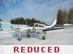 | 1974 | Cessna 310Q  5,322 TTSN, 623 SMOH - Left, 770 SMOH - Right  Immaculate C-310 with Recent Paint - Excellent Condition! | $165,000 USD
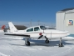 | 1976 | Cessna 310R  15,856 TTSN, 1,168 SMOH - Left, 624 SMOH - Right  An Exceptional Maintained Canadian Commercial Aircraft! | Make Offer
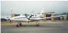 | 1984 | Cessna T-303 Crusader  3934 TTSN, 0 SMOH - Left, 167 SMOH- Right  Canadian Commercially Operated Aircraft | $ 245,000 USD
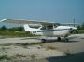 | 1976 | Cessna T210L  5,259 TTSN, Only 85 SMOH, Immaculate Aircraft, Recent Paint and Interior. Looks Like New In and Out - Must Sell! | Make Offer
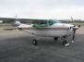 | 1978 | Cessna T210M  5427 TTAF, 1135 SMOH, 280 SPOH.  Canadian Commercial Aircraft with King IFR Avionics | $159,000 USD
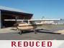 | 1971 | Cessna Turbo 210K  4,200 TTSN, 120 SMOH. 320 SPOH, Always Hangared. Well Maintained Canadian Aircraft. | $129,900 USD
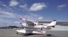 | 1975 | Cessna U206  3,262 TTSN, 157 SMOH. New Hartzell Prop, New Paint. Garmin 430 GPS. Owner Must sell. | Make Offer!
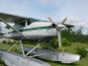 | 1970 | Cessna U206E  7,532 TTSN, 382 SMOH. Repainted in 2000, No Corrosion. Owner Must Sell!! | Make an Offer!
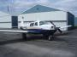 | 1977 | Mooney 201 (M20J) Turbocharged  1,940 TTSN, 309 SMOH, Garmin/King IFR Certified. Recent Paint and Interior. A Well Maintained Privately Owned Aircraft. | $154,900 USD
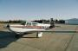 | 1981 | Mooney 231 (M20K)  2,300 TTSN, 1,384 SMOH, IFR Certified with TKS De-Ice System - Excellent Condition! | $184,000 USD
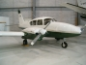 | 1960 | Piper Aztec  4,860 TTSN, 839 SMOH, Complete Avionics Upgrade - 2005 with New Custom Panel. Painted in 1999, New Interior. | $159,000.00
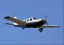 | 1974 | Piper Cherokee Six  3,970 TTSN, 840 SMOH. Excellent condition aircraft. Canadian Registered. IFR aircraft, Fresh Annual Completed March 2008 | Make An Offer!
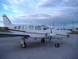 | 1977 | Piper Navajo  7,125 TTSN, 57 SMOH (R), 1624 SMOH (L). Full De-ice, Cargo Door. Owner Motivated To Sell. | $247,900 USD
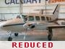 | 1975 | Piper Navajo CR  11,724 TT, 25 SMOH L/R. Commercially Owned and Maintained, Complete Records | $235,000 USD
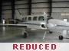 | 1977 | Piper Navajo CR  8,025 TT, 2,213 SMOH (L),487 SMOH (R), 487 SPOH L/R, Canadian Commercially Operated & Maintained. NDH | $205,000 USD
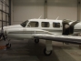 | 1976 | Piper PA31 Navajo  3,950 TTSN, 1,300 SMOH Left/Right, Garmin IFR Avionics, Exceptional Aircraft with Complete Logs - No damage history | $298,000 USD
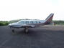 | 1968 | Piper PA31-310 Navajo  10,798 TTSN, 206 SMOH - L/R, 1,157/206 SPOH, Privately Owned Aircraft in Very Good Condition. Trades Considered! | $139,500 USD
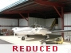 | 1978 | Piper Seneca II  3,761 TTSN, 1,950 SMOH (L/R). Club Seating. Known Icing, Long Range Fuel. | $89,900 USD
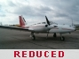 | 1979 | Piper Seneca II  6,872 TTSN, 1,264 SMOH, IFR Certified, Known Ice, Garmin IFR GPS, A Well Maintained Canadian Aircraft. | $140,000 USD
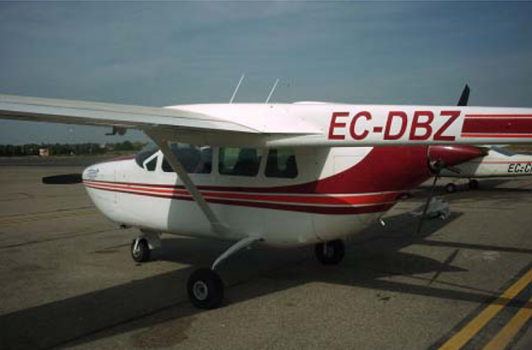 | 1971 | CESSNA F337F PUSH PULL  Total Time Airframe 2506:50 Hours  • 5 Passenger + 1 Pilot  • Maintenance EASA 145  • IFR | 105.000 Euros
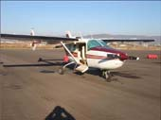 | 1975 | CESSNA 337-G PUSH PULL  Total Time Airframe 3.666:12 Hours  • 5 Passenger + 1 Pilot  • Maintenance EASA 145  • IFR  • GPS SKYFORCE COLOURSKYMAP | 130.000 Euros
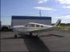 | 1978 | Piper Turbo Arrow  3,109 TTSN, 1,518 SMOH An exceptional aircraft with upgraded Garmin IFR Avionics and New Interior - Canadian Registered. | $139,900 USD
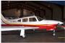 | 1978 | Piper Turbo Arrow  4,066 TTSN, 645 SMOH. Collins Avionics - IFR Certified.  New Paint and Interior in 2004! | $149,000 USD
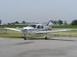 | 1974 | Rockwell Commander 112A  2,155 TTSN, 494 SMOH - Immaculate, Clean,  Low Time Commander 112! | $105,900 USD
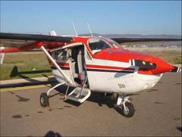 | 1973 | CESSNA FT337GP PUSH PULL  Total Time Airframe 1499:10 Hours  • 5 Passenger + 1 Pilot  • Maintenance EASA 145  • IFR  • GPS GARMIN G155 | 150.000 Euros
FOTO NO DISPONIBLE | 1975 | CESSNA 182P  Total Time Airframe 3184:57 Hours  • 3 Passenger + 1 Pilot  • Maintenance EASA 145  • VFR | 90.000 Euros
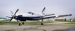 | 1991 | Socata TBM 700A  3,197 TTSN, 115 SHOT, This Exceptional Aircraft was Upgraded with New Paint and Interior in2003 and is in "Like New" Condition! | $1,680,000 USD

Se aceptan ofertas serias.

